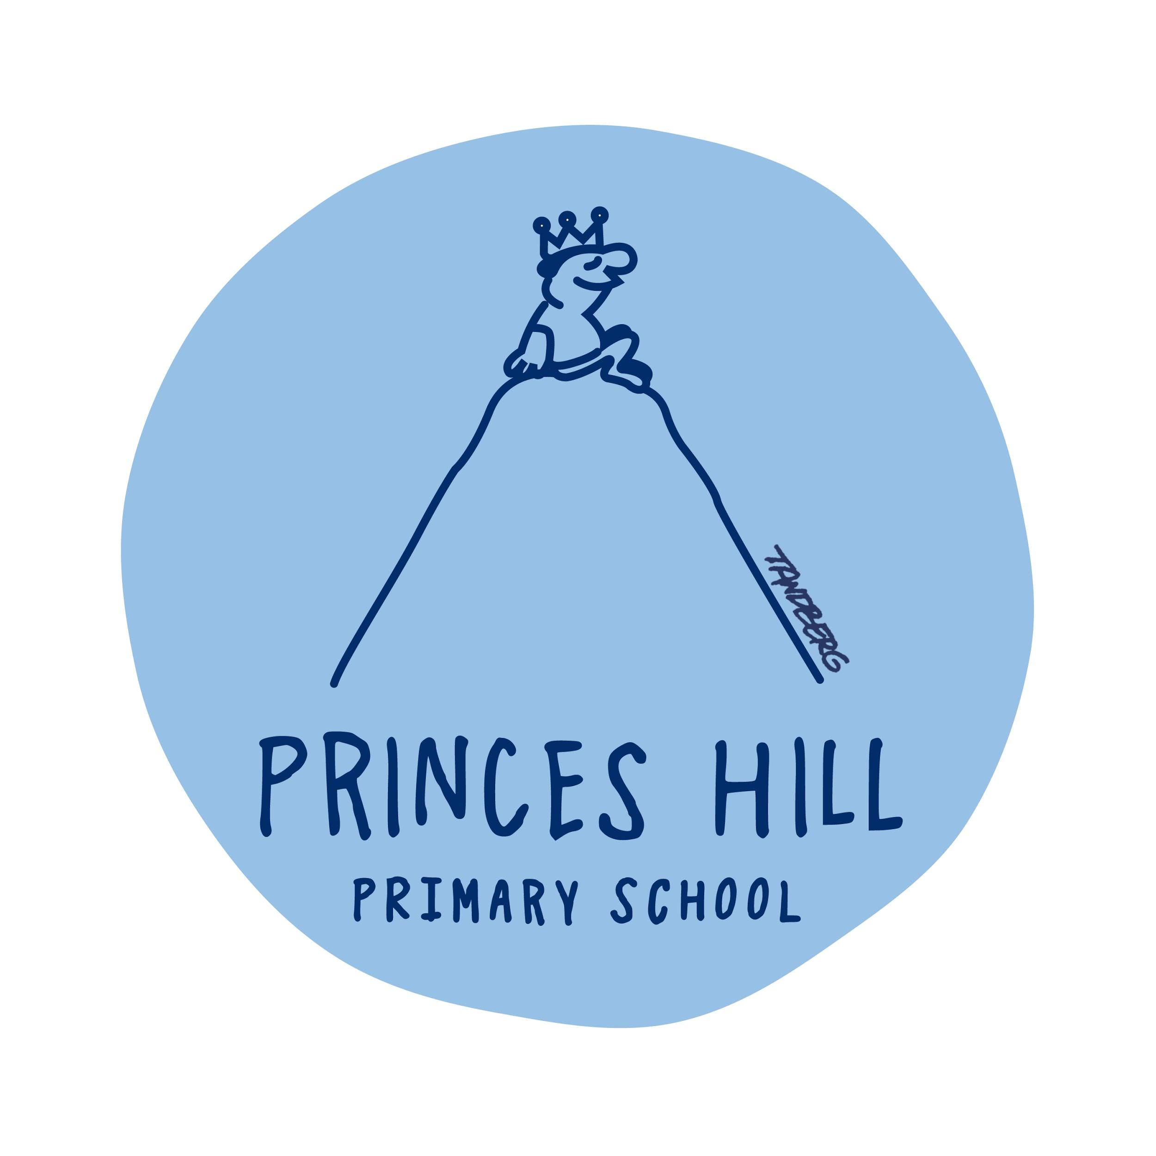
STUDENT CODE OF CONDUCT
School Values and behaviours

One Community
- Walk in their shoes
- Own your own behaviour

Expanding Possibilities
- Demonstrate quality and excellence in learning and teaching
- Make learning meaningful

Strong and Capable Children
- Act in the best interests of all our children
- Be inspired by the school and where our primary school journey can take us

Rights and Responsibilities
- Everyone has the right to be safe
- Everyone has the right to learn

Protocols
- We listen
- Our words are kind
- We do our best and help others to do their best
- We move and play safely
- We look after ourselves, others and our environment

The school’s code of conduct for students has been formulated on the basis of the basis of the following principles:
- The student’s right to feel safe.
- The student’s right to be listened to and to be valued.
- The student’s right to learn and play without disruption and interference in a safe and harassment free environment.
- The need for all students to be treated with respect, fairness and kindness.
- The importance of developing the student’s self-discipline and self-esteem.
- The expectation that students will be courteous, polite and well mannered.
- The fostering of a sense of pride in being a student at Princes Hill Primary School.
- The reinforcement of positive behaviour.

Guidelines:
- There are logical consequences for unacceptable behaviour.
- Problems need to be resolved in a calm, sensible and fair manner.
- School and personal property needs to be respected.
- Physical and verbal harassment is unacceptable.
- Play within the school grounds needs to be safe.
- Children must be safe at all times.

Strategies:
Princes Hill Primary School is committed to a positive and consistent approach to the implementation of our discipline procedures. We endeavour to recognise and promote positive behaviour by employing the following strategies:
- Expecting students to accept responsibility for their behaviour.
- Implementation of weekly social and emotional learning sessions through the Resilience Portal and Respectful Relationships programs
- Ensuring that students are aware of the consequences of their behaviour.
- Kids Matter professional development for staff
- Negotiating clear classroom rights and responsibilities, consistent with the Student Code of Conduct.
- Providing adequate supervision in the classroom and playground.
- Modelling appropriate behaviour.
- Encouraging friendships through ‘buddy’ systems and organised activities at recess breaks.
- Implementing procedures from Ramon Lewis, ‘Developmental Behaviour Management Program’ which nominates safety and learning as primary rights and responsibilities, and emphasises respectful interactions.
- Developing student safety plans where appropriate.
- Applying consistent consequences and positive behaviour management practices.
- Providing learning environments which continually reinforce the development of interpersonal and emotional intelligence.

